BRAINSTORMING – IDEA GENERATION – PRIORITIZATION

Date: 21-12-2025
Project Name : Automated Network Request Management in ServiceNow

Overview
This document captures the brainstorming, idea generation, and prioritization activities for the Automated Network Request Management project in ServiceNow.

Step 1: Team Collaboration & Problem Identification
Stakeholders including end users, IT administrators, network teams, and approvers participated in identifying key issues in the manual network request process.

Identified Problem Statement
Manual handling of network service requests leads to delays, lack of transparency, and increased workload for IT teams.

ServiceNow Workflow Reference
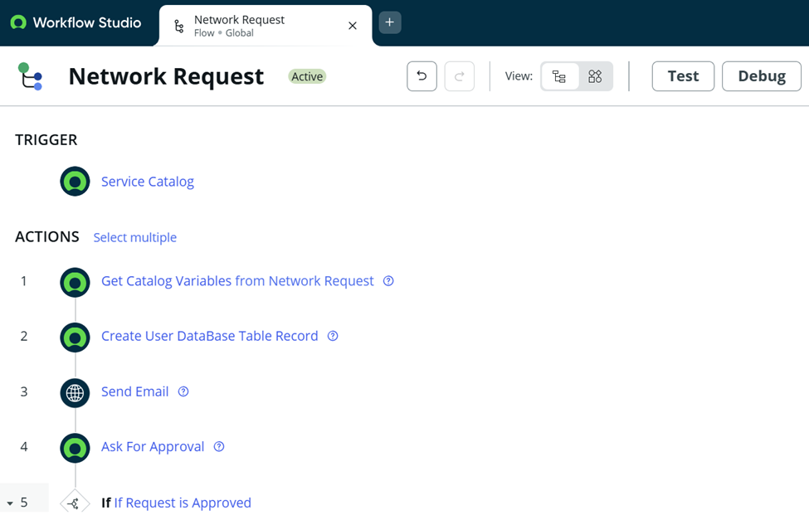

Step 2: Brainstorming & Idea Generation
• Centralized Service Catalog for network requests
• Dynamic forms with conditional logic
• Automated approval workflows using Flow Designer
• Custom network database table
• Email notifications at every stage
• Role-based access using ACLs

Step 3: Idea Prioritization
High Priority: Service Catalog, Dynamic Forms, Approval Automation
Medium Priority: Custom Database, Notifications
Low Priority: Advanced reporting and analytics

Final Outcome
The ideation phase concluded with a scalable automation solution leveraging ServiceNow best practices to streamline network request management.

